CC- Employee Management System Develop a menu-driven Employee Management System that manages employee records (Emp ID, Emp Name, email, birth date, Department) in Salesforce using console based.
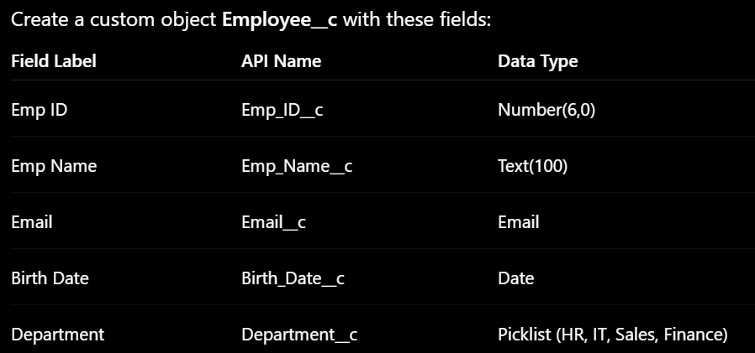

Apex
public class EmployeeManagementSystem {
// CREATE Employee
public static void addEmployee(Integer empId, String empName,
String email, Date birthDate,
String department) {
try {
Employee__c emp = new Employee__c();
emp.Emp_ID__c = empId;
emp.Emp_Name__c = empName;
emp.Email__c = email;
emp.Birth_Date__c = birthDate;
emp.Department__c = department;

insert emp;
System.debug('Employee Added Successfully');
}
catch(Exception e) {
System.debug('Error: ' + e.getMessage());
}
}
// VIEW All Employees
public static void viewEmployees() {
try {
List<Employee__c> empList = [
SELECT Id, Emp_ID__c, Emp_Name__c,
Email__c, Birth_Date__c,
Department__c
FROM Employee__c
];
System.debug('----- Employee Records -----');
for(Employee__c emp : empList) {
System.debug(
'Emp ID: ' + emp.Emp_ID__c +
' | Name: ' + emp.Emp_Name__c +
' | Email: ' + emp.Email__c +
' | Birth Date: ' + emp.Birth_Date__c +
' | Department: ' + emp.Department__c
);
}
}
catch(Exception e) {
System.debug('Error: ' + e.getMessage());
}
}
// UPDATE Employee Department
public static void updateDepartment(Integer empId,
String newDepartment) {
try {
Employee__c emp = [
SELECT Id, Department__c
FROM Employee__c
WHERE Emp_ID__c = :empId
LIMIT 1
];
emp.Department__c = newDepartment;
update emp;
System.debug('Department Updated Successfully');
}
catch(Exception e) {
System.debug('Error: ' + e.getMessage());
}
}
// DELETE Employee
public static void deleteEmployee(Integer empId) {
try {
Employee__c emp = [
SELECT Id
FROM Employee__c
WHERE Emp_ID__c = :empId
LIMIT 1
];
delete emp;
System.debug('Employee Deleted Successfully');
}
catch(Exception e) {
System.debug('Error: ' + e.getMessage());
}
}
// MENU METHOD
public static void menu() {
System.debug('========= Employee Management System =========');
System.debug('1. Add Employee');
System.debug('2. View Employees');
System.debug('3. Update Employee Department');
System.debug('4. Delete Employee');
System.debug('Call methods manually from Execute Anonymous Window');
}
}

Console
// Show Menu
EmployeeManagementSystem.menu();

// Add Employee
EmployeeManagementSystem.addEmployee(
101,
'Rahul Sharma',
'rahul@gmail.com',
Date.newInstance(2001, 5, 10),
'IT'
);

// View Employees
EmployeeManagementSystem.viewEmployees();

// Update Department
EmployeeManagementSystem.updateDepartment(
101,
'HR'
);

// Delete Employee
EmployeeManagementSystem.deleteEmployee(101);

CC- Bank Account System Develop a menu-driven Bank Account System that manages Customer records (Emp ID, Emp Name, email, birth date, Department) in Salesforce using console based.
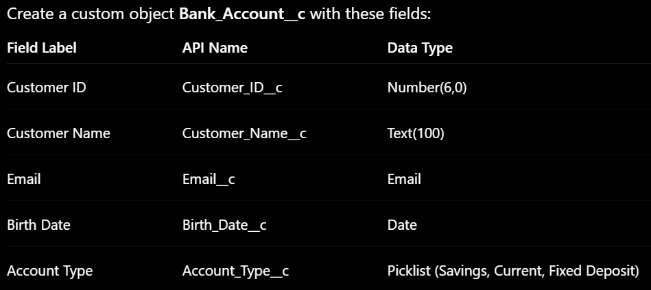

Apex
public class BankAccountSystem {
// CREATE Customer
public static void addCustomer(Integer customerId,
String customerName,
String email,
Date birthDate,
String accountType) {
try {
Bank_Account__c cust = new Bank_Account__c();
cust.Customer_ID__c = customerId;
cust.Customer_Name__c = customerName;
cust.Email__c = email;
cust.Birth_Date__c = birthDate;
cust.Account_Type__c = accountType;
insert cust;
System.debug('Customer Added Successfully');
}
catch(Exception e) {
System.debug('Error: ' + e.getMessage());
}
}
// VIEW All Customers
public static void viewCustomers() {
try {
List<Bank_Account__c> custList = [
SELECT Id,
Customer_ID__c,
Customer_Name__c,
Email__c,
Birth_Date__c,
Account_Type__c
FROM Bank_Account__c
];
System.debug('----- Customer Records -----');
for(Bank_Account__c cust : custList) {
System.debug(
'Customer ID: ' + cust.Customer_ID__c +
' | Name: ' + cust.Customer_Name__c +
' | Email: ' + cust.Email__c +
' | Birth Date: ' + cust.Birth_Date__c +
' | Account Type: ' + cust.Account_Type__c
);
}
}
catch(Exception e) {
System.debug('Error: ' + e.getMessage());
}
}
// UPDATE Account Type
public static void updateAccountType(Integer customerId,
String newAccountType) {
try {
Bank_Account__c cust = [
SELECT Id, Account_Type__c
FROM Bank_Account__c
WHERE Customer_ID__c = :customerId
LIMIT 1
];
cust.Account_Type__c = newAccountType;
update cust;
System.debug('Account Type Updated Successfully');
}
catch(Exception e) {
System.debug('Error: ' + e.getMessage());
}
}
// DELETE Customer
public static void deleteCustomer(Integer customerId) {
try {
Bank_Account__c cust = [
SELECT Id
FROM Bank_Account__c
WHERE Customer_ID__c = :customerId
LIMIT 1
];
delete cust;
System.debug('Customer Deleted Successfully');
}
catch(Exception e) {
System.debug('Error: ' + e.getMessage());
}
}
// MENU METHOD
public static void menu() {
System.debug('========= Bank Account System =========');
System.debug('1. Add Customer');
System.debug('2. View Customers');
System.debug('3. Update Account Type');
System.debug('4. Delete Customer');
System.debug('Call methods manually from Execute Anonymous Window');
}
}

Console
// Show Menu
BankAccountSystem.menu();

// Add Customer
BankAccountSystem.addCustomer(
201,
'Amit Patil',
'amit@gmail.com',
Date.newInstance(1999, 8, 15),
'Savings'
);

// View Customers
BankAccountSystem.viewCustomers();

// Update Account Type
BankAccountSystem.updateAccountType(
201,
'Current'
);
BankAccountSystem.viewCustomers();

// Delete Customer
BankAccountSystem.deleteCustomer(201);
BankAccountSystem.viewCustomers();

